Rim cable cover:

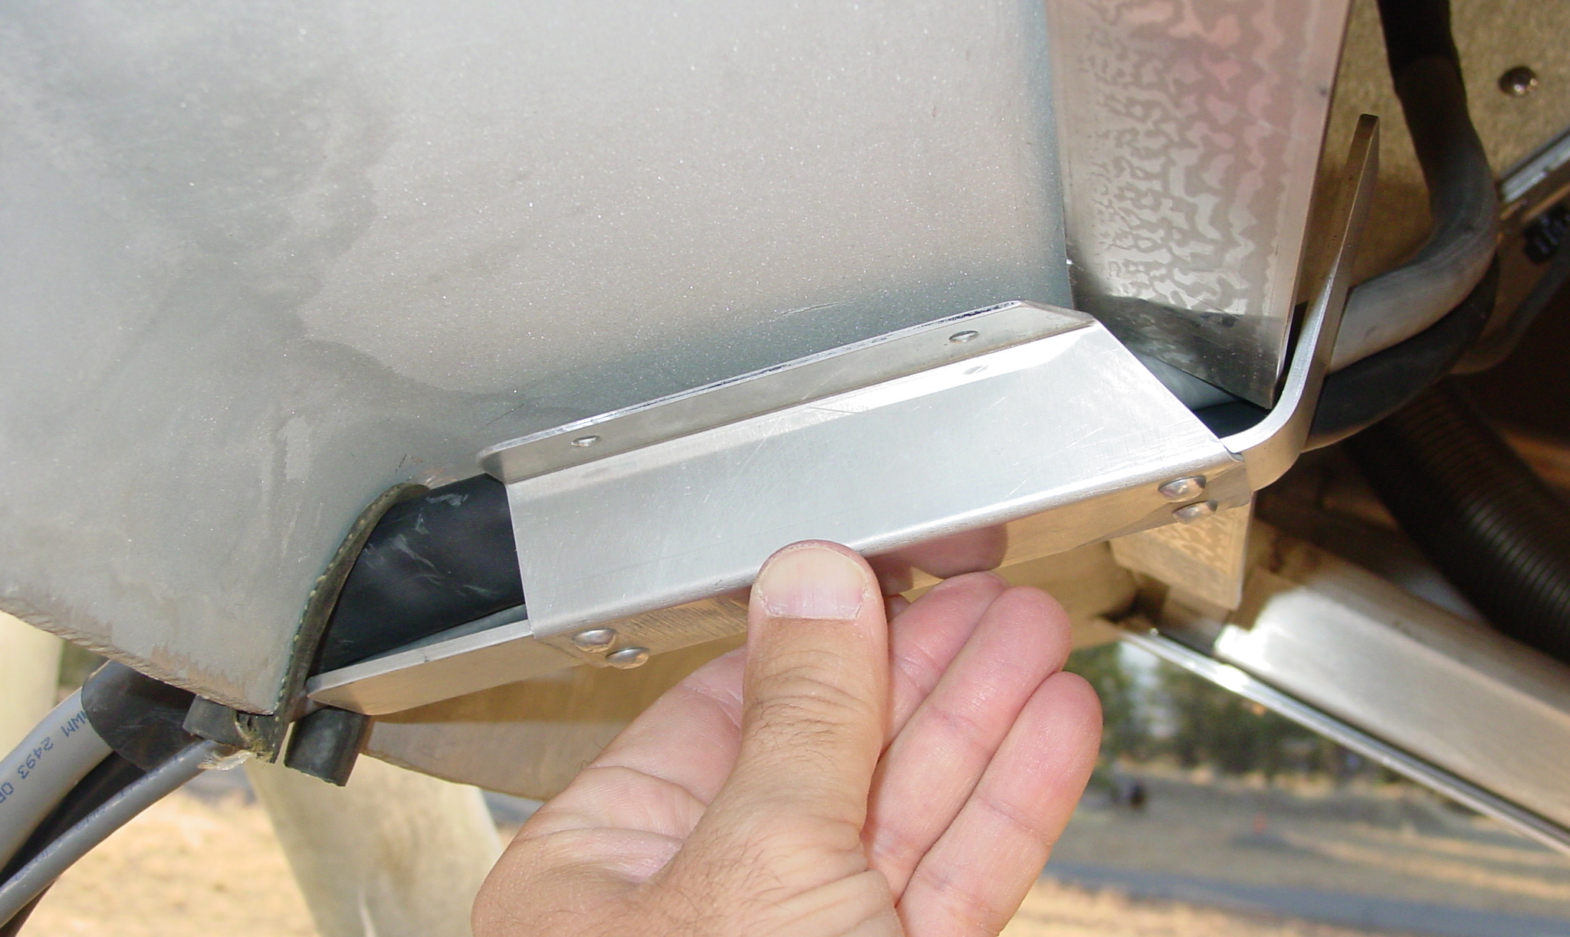
This flange isn’t really necessary?
Maybe this side should terminate here?
longer?

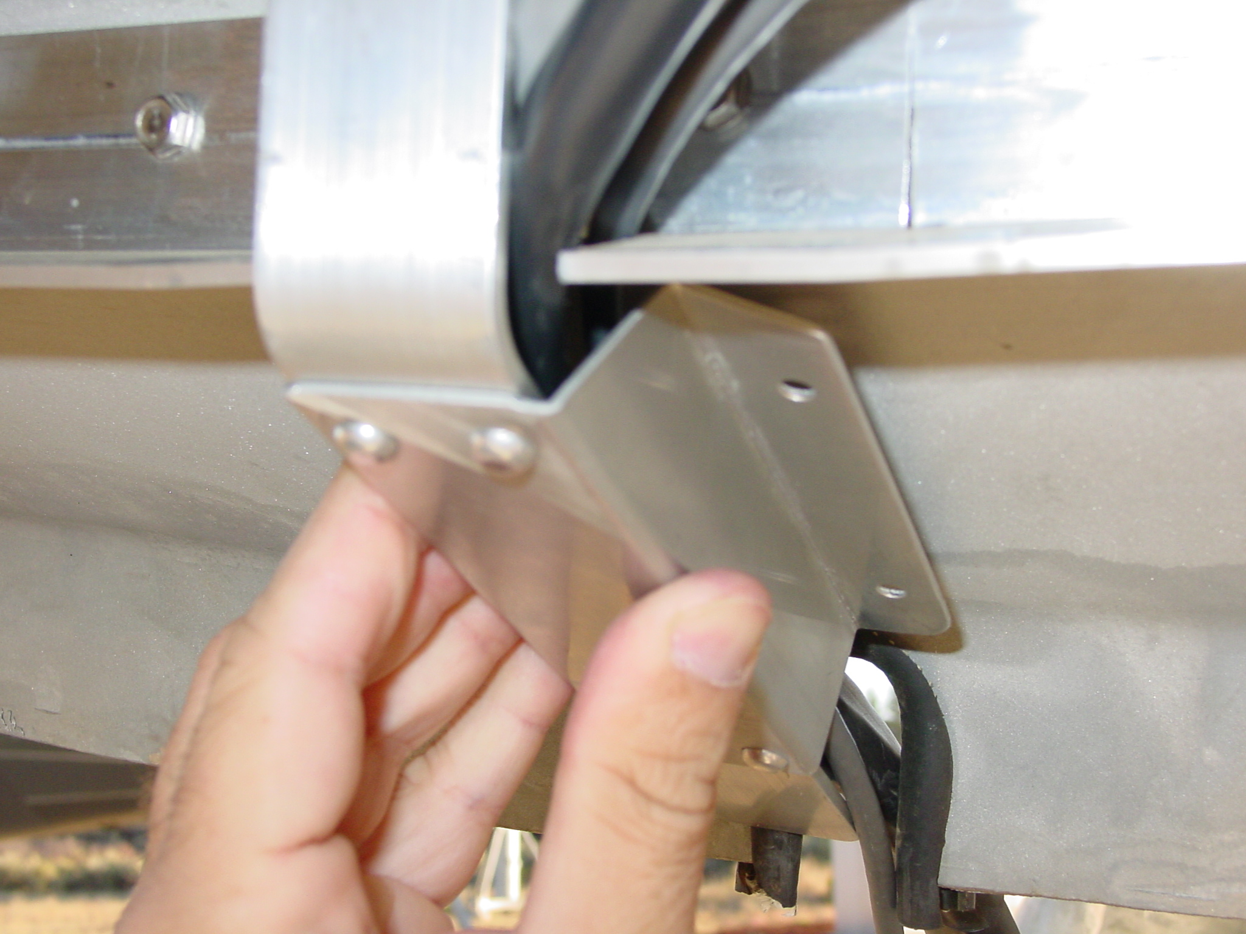
The cables want to veer off to the right

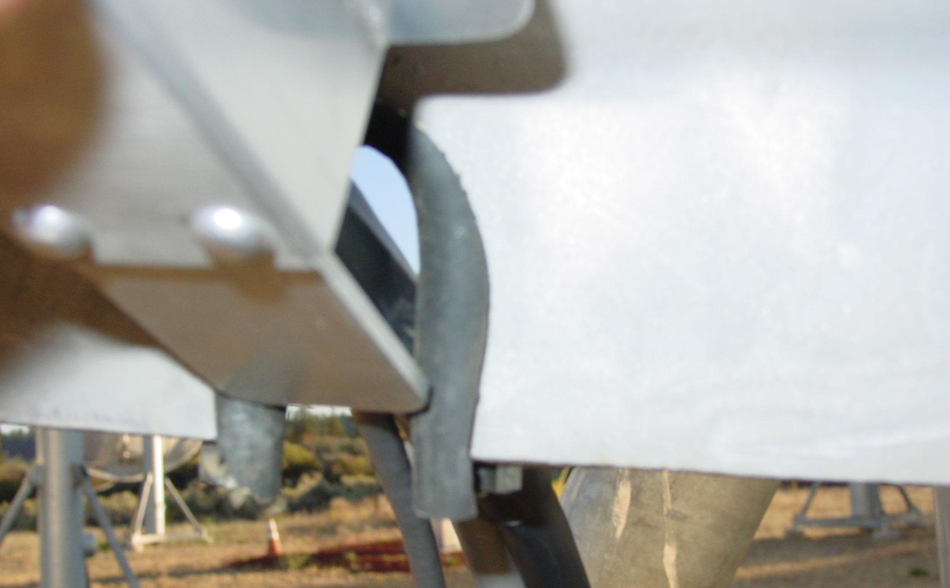
~ ³/₄″

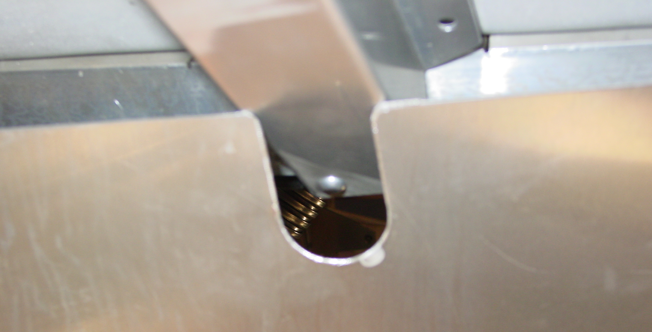
Just needs renotching.

Power supply bracket:

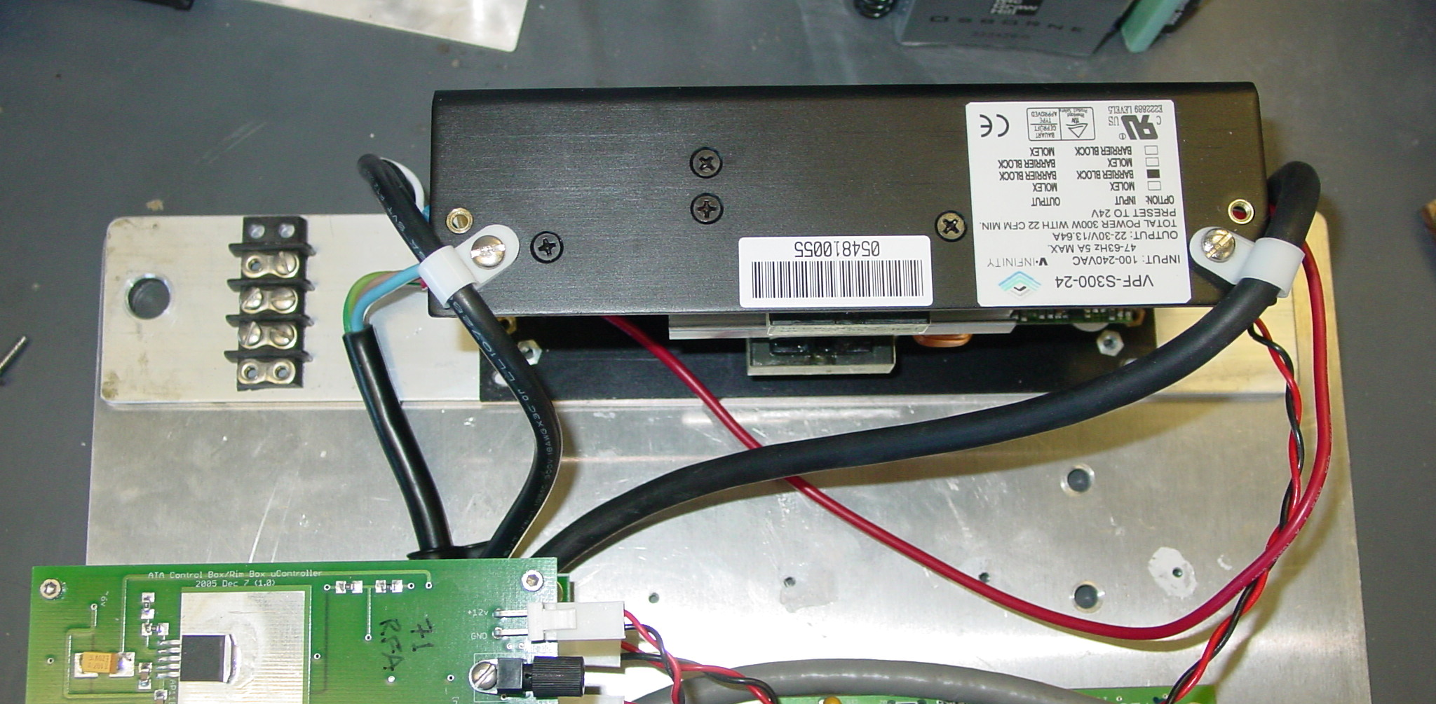
This looks like an OK place for a terminal strip.

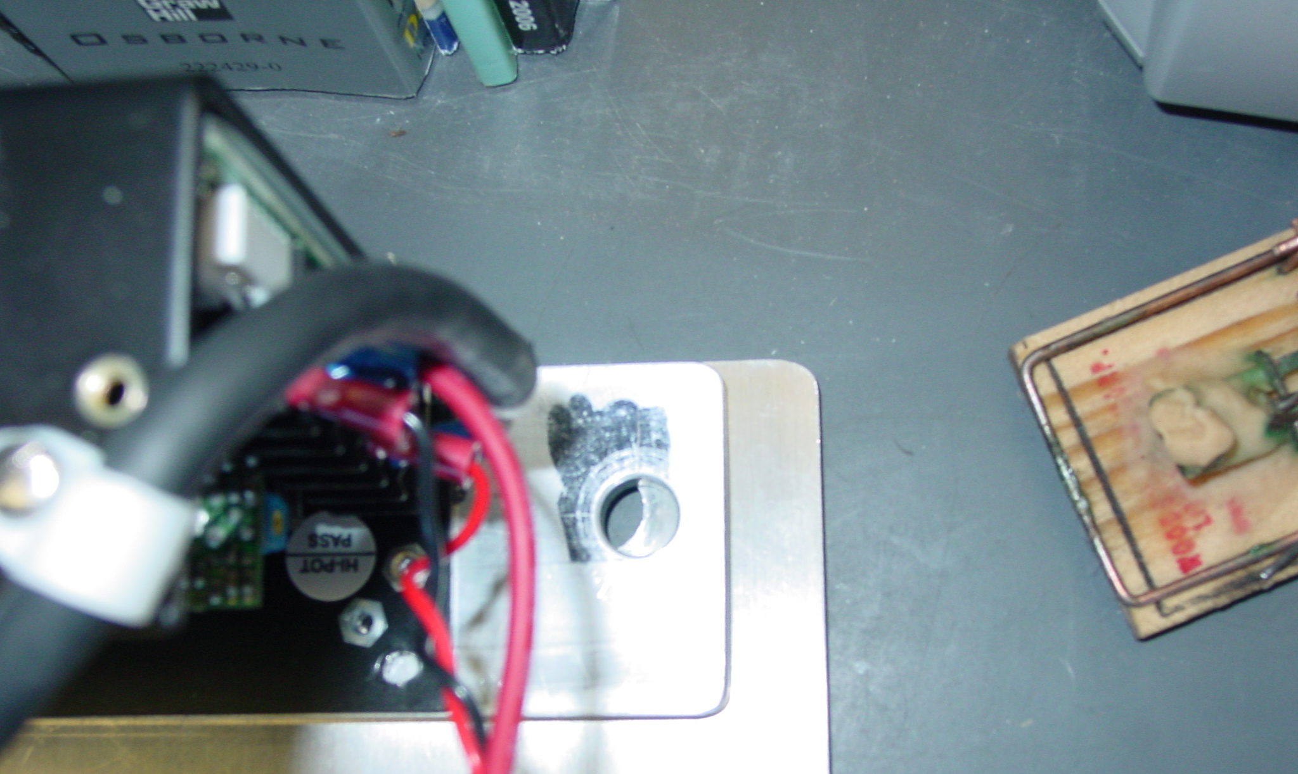
Not quite the right hole spacing.
Needs new cheese.

